Smart Irrigation Decision Support System Using Simulated Soil Moisture and Weather Data
A CAPSTONE PROJECT REPORT
Submitted in the partial fulfilment for the Course of
CSA0904– Programming in Java
to the award of the degree of
BACHELOR OF ENGINEERING
IN
COMPUTER SCIENCE AND ENGINEERING
Submitted by
O. Bhanu Prakash Reddy-192372075
P.Srihari-192372222
Kandath Haneesh-192324084
Mandati Sharan Mahi reddy-192324082
- Ajay Antony Raj-192524414
Under the Supervision of
DR. Thalapathy RajaSekaran

SIMATS ENGINEERING
Saveetha Institute of Medical and Technical Sciences
Chennai-602105
August 2026
 | SIMATS ENGINEERING  Saveetha Institute of Medical and Technical Sciences  Chennai-602105 | 
DECLARATION
We, O. Bhanu Prakash Reddy-192372075, P.Srihari-192372222, Kandath Haneesh-192324084, Mandati Sharan Mahi reddy-192324082, A. Ajay Antony Raj-192524414 of the Computer Science and Engineering, Saveetha Institute of Medical and Technical Sciences, Saveetha University, Chennai, hereby declare that the Capstone Project Work entitled ‘Smart Irrigation Decision Support System Using Simulated Soil Moisture and Weather Data’ is the result of our own bonafide efforts. To the best of our knowledge, the work presented herein is original, accurate, and has been carried out in accordance with principles of engineering ethics.

Place:
Date:
Signature of the Students with Names
O. Bhanu Prakash Reddy-192372075
P.Srihari-192372222
Kandath Haneesh-192324084
Mandati Sharan Mahi reddy-192324082
- Ajay Antony Raj-192524414

 | SIMATS ENGINEERING  Saveetha Institute of Medical and Technical Sciences  Chennai-602105 | 
BONAFIDE CERTIFICATE
This is to certify that the Capstone Project entitled “Smart Irrigation Decision Support System Using Simulated Soil Moisture and Weather Data” has been carried out by O. Bhanu Prakash Reddy-192372075 P.Srihari-192372222 Kandath Haneesh-192324084 Mandati Sharan Mahi reddy-192324082 A. Ajay Antony Raj-192524414under the supervision of [Guide Name] and is submitted in partial fulfilment of the requirements for the current semester of the B.Tech -CSE program at Saveetha Institute of Medical and Technical Sciences, Chennai.

SIGNATURE
DR. Thalapathy Rajasekaran
Designation
Department Name (Branch)
Saveetha School of Engineering
SIMATS
Submitted for the Project work Viva-Voce held on ____________________________________.
INTERNAL EXAMINER

ACKNOWLEDGEMENT
We would like to express our heartfelt gratitude to all those who supported and guided us throughout the successful completion of our Capstone Project. We are deeply thankful to our respected Founder and Chancellor, Dr. N.M. Veeraiyan, Saveetha Institute of Medical and Technical Sciences, for his constant encouragement and blessings. We also express our sincere thanks to our Pro-Chancellor, Dr. Deepak Nallaswamy Veeraiyan, and our Vice-Chancellor, Dr. S. Suresh Kumar, for their visionary leadership and moral support during the course of this project.
We are truly grateful to our Director, Dr. Ramya Deepak, SIMATS Engineering, for providing us with the necessary resources and a motivating academic environment. Our special thanks to our Principal, Dr. B. Ramesh for granting us access to the institute’s facilities and encouraging us throughout the process.
We are especially indebted to our guide, Guide Name for his creative suggestions, consistent feedback, and unwavering support during each stage of the project. We also express our gratitude to the Project Coordinators, Review Panel Members (Internal and External), and the entire faculty team for their constructive feedback and valuable inputs that helped improve the quality of our work. Finally, we thank all faculty members, lab technicians, our parents, and friends for their continuous encouragement and support.

Signature With Student Name
O. Bhanu Prakash Reddy-192372075
P.Srihari-192372222
Kandath Haneesh-192324084
Mandati Sharan Mahi reddy-192324082
- Ajay Antony Raj-192524414
Abstract
Irrigation scheduling in small and medium-sized farms is still largely governed by manual judgement and fixed calendar routines, which frequently results in over-watering or under-watering because they do not account for real-time soil and weather conditions. Physical Internet-of-Things (IoT) soil-moisture sensor networks can solve this problem but remain financially and technically out of reach for many smallholder farmers. This capstone project presents AgroSense, a web-based Smart Irrigation Decision Support System that demonstrates how an irrigation-scheduling decision engine can be built and evaluated entirely in software, without any physical hardware, by combining live weather data with a realistic simulated soil-moisture signal. The system is implemented as a Java Spring Boot MVC web application with a persistent H2 database, a Thymeleaf-rendered dashboard, and interactive Leaflet.js maps for farm geolocation. On every simulation run, the system retrieves live, real-time weather observations (temperature, humidity, precipitation, and weather condition) for the farm's exact GPS coordinates from the free Open-Meteo Forecast API, and combines this with a soil-moisture value generated within a realistic 10-60 percent operating range to stand in for a physical sensor reading. A priority-ordered rule chain then evaluates this combined environmental snapshot and issues an irrigation decision -- ON, OFF, or DELAY -- together with a computed water quantity, and automatically dispatches a Slack alert to the farmer when the situation is time-sensitive. Every simulation is persisted to a history log that feeds a KPI dashboard and trend charts. This report documents the background, design, implementation, and evaluation of the system, and demonstrates that a no-hardware, simulation-plus-live-weather approach can provide a credible, low-cost decision-support pathway for irrigation scheduling, while identifying the integration of real IoT sensor feeds as the primary direction for future work.
Table of Contents
Section | Page
Abstract | 5
List of Figures and Tables | 7
Acknowledgments | 8
Chapter 1: Introduction | 9
1.1 Background Information | 9
1.2 Project Objectives | 9
1.3 Significance | 10
1.4 Scope | 10
1.5 Methodology Overview | 11
Chapter 2: Problem Identification and Analysis | 12
2.1 Description of the Problem | 12
2.2 Evidence of the Problem | 12
2.3 Stakeholders | 13
2.4 Supporting Data/Research | 13
Chapter 3: Solution Design and Implementation | 15
3.1 Development and Design Process | 15
3.2 Tools and Technologies Used | 16
3.3 Solution Overview | 18
3.4 Engineering Standards Applied | 22
3.5 Solution Justification | 23
Chapter 4: Results and Recommendations | 24
4.1 Evaluation of Results | 24
4.2 Challenges Encountered | 25
4.3 Possible Improvements | 25
4.4 Recommendations | 25
Chapter 5: Reflection on Learning and Personal Development | 27
Chapter 6: Conclusion | 30
References | 31
Appendices | 32
List of Figures and Tables
List of Figures
Figure | Page
Figure 1: AgroSense System Architecture (MVC, Spring Boot) | 16
Figure 2: End-to-End Simulation Flow | 18
Figure 3: Priority-Ordered Irrigation Decision Rule Chain | 20
Figure 4: Sample History and Analytics Trend (12 Simulation Events) | 21
List of Tables
Table | Page
Table 1: Tools and Technologies Used in the Project | 17
Table 2: Key Data Fields Across Core Models | 22
Table 3: Decision Rule Summary | 22
Table 4: Engineering Standards Applied | 23
Table 5: KPI Tiles and Calculations | 24
Acknowledgments
We are grateful to our project guide, [Guide Name], for the technical direction and consistent feedback provided throughout the design and development of AgroSense. We also thank the faculty of the [Department Name] for their support and for providing access to the computing resources needed to build and test the application.
We acknowledge the Open-Meteo project for providing free, keyless access to real-time weather data, and the Slack platform for its messaging API, both of which were central to demonstrating a realistic, no-hardware irrigation decision-support workflow. Finally, we thank our families and peers for their encouragement throughout this capstone project.
Chapter 1: Introduction
1.1 Background Information
Agriculture accounts for the largest share of freshwater consumption in most developing economies, and inefficient irrigation is one of the leading causes of water wastage in the sector. In India specifically, a large proportion of farmland is managed by smallholder farmers who typically irrigate on a fixed schedule or based on visual inspection of the soil, rather than on objective measurements of soil moisture, temperature, humidity, or upcoming rainfall. This frequently leads to over-irrigation, which wastes water and can damage root systems, or under-irrigation, which reduces crop yield.
Precision-agriculture solutions built on physical Internet-of-Things (IoT) soil-moisture sensors, telemetry gateways, and automated valves can address this problem directly, but the upfront hardware cost, the need for reliable rural connectivity, and ongoing maintenance place these solutions out of reach for many smallholder farms. This creates a gap for software-only decision-support tools that can still meaningfully improve irrigation timing by combining whatever environmental information is available -- most importantly, live weather forecasts, which are now freely available through public APIs -- with a stand-in for the soil-moisture reading that a physical sensor would otherwise provide.
This capstone project addresses that gap directly. AgroSense is a web-based Smart Irrigation Decision Support System that deliberately uses no physical hardware of any kind. Soil moisture, which would normally come from a buried capacitive or resistive sensor, is instead generated as a realistic simulated value within an operating range representative of real field conditions. Weather data, by contrast, is not simulated: it is fetched live, in real time, from the free Open-Meteo Forecast API using the farm's exact GPS coordinates, so that every irrigation decision reflects the true current weather at the farm's location at the moment the simulation is run.
1.2 Project Objectives
The primary objectives of this capstone project are as follows:
- To design and implement a full-stack web application that models the irrigation-scheduling decision process for a farm without relying on any physical IoT hardware.
- To integrate a live, real-time weather data source (the Open-Meteo Forecast API) so that temperature, humidity, rainfall, and weather condition reflect true current conditions at the farm's GPS location.
- To generate a realistic simulated soil-moisture signal, in a configurable operating range, that stands in for a physical soil-moisture sensor reading.
- To implement a transparent, priority-ordered rule-based decision engine that converts the combined environmental snapshot into an actionable irrigation decision and an estimated water quantity.
- To provide automated farmer notifications through a Slack integration, with deduplication logic to prevent alert spam.
- To provide a history and analytics dashboard that allows a farmer or researcher to review past simulations, water usage, and environmental trends over time.
1.3 Significance
This project is significant because it demonstrates that meaningful irrigation decision support does not have to wait for full IoT hardware deployment. By combining a live, authoritative weather feed with a well-reasoned simulated soil-moisture value, the system produces irrigation recommendations that already incorporate the single largest source of day-to-day variability in irrigation need -- the weather -- while leaving a clean integration point for a real soil-moisture sensor to be added later without any change to the decision logic itself.
For smallholder farmers in particular, a software-only decision-support tool of this kind can be deployed at effectively zero marginal hardware cost, using only a smartphone or shared computer with an internet connection. For agricultural-technology researchers and students, the project also serves as a template for how rule-based decision engines, live external APIs, and messaging integrations can be combined cleanly within a layered MVC architecture.
1.4 Scope
The scope of this capstone project is explicitly limited to a software simulation: no physical hardware, sensors, or actuators of any kind are used or required to run the system. Soil moisture is generated as a simulated value within a configurable range (10-60 percent by default) rather than measured by a physical sensor. Weather data, in contrast, is not simulated: it is retrieved live from the Open-Meteo Forecast and Geocoding APIs for the farm's real GPS coordinates (or resolved from a typed location name), so temperature, humidity, rainfall, and weather condition are genuine real-time values at the moment each simulation is run.
The system supports multiple users, each managing multiple farms with independent crop type, soil type, farm area, and GPS location. The decision engine, alerting logic, and history/analytics dashboard are fully implemented and functional. The scope does not extend to physical actuation of irrigation valves, to multi-user role-based access control, or to machine-learning-based prediction; these are identified as future enhancements in Chapter 4.
1.5 Methodology Overview
The project was developed in five stages. First, requirements were gathered around a realistic smallholder-farm irrigation workflow: register, add a farm with a GPS location, run a simulation, receive a decision and an alert, and review history. Second, a layered Model-View-Controller architecture was designed using Spring Boot, Spring Data JPA, and Thymeleaf, backed by an embedded, file-persistent H2 database. Third, the core services were implemented: authentication with BCrypt password hashing, farm management with an interactive Leaflet.js map, a simulation service that fetches live weather from Open-Meteo and generates simulated soil moisture, a rule-based decision engine, a Slack-based alert service with cooldown-based deduplication, and a history/analytics service. Fourth, the system was tested end-to-end by running simulations against real farm locations and verifying that the correct rule fired, the correct water quantity was computed, and the correct Slack alert status was returned. Finally, the results were analysed and a set of recommendations for future hardware integration and scaling were developed.
Chapter 2: Problem Identification and Analysis
2.1 Description of the Problem
The core problem this project addresses is that irrigation decisions on most smallholder farms are made without objective, real-time environmental information. A farmer typically decides whether to irrigate today based on habit, a fixed weekly schedule, or a quick visual check of the topsoil, none of which reliably captures the combination of factors that actually determines irrigation need: how much moisture remains in the root zone, how hot and humid it currently is, and whether rain is expected in the next few hours. The result is a systematic tendency toward over-irrigation (wasting water and, in some soils, promoting root disease) or under-irrigation (stressing the crop and reducing yield).
A second, related problem is that the 'gold standard' solution -- a network of physical soil-moisture sensors connected to a cloud platform -- is not accessible to most smallholder farmers because of hardware cost, installation effort, and the need for reasonably reliable rural network connectivity to transmit sensor telemetry. This leaves a substantial gap between 'no decision support at all' and 'full IoT deployment', a gap that a software-only decision-support tool combining live weather data with a realistic simulated soil-moisture signal is well positioned to fill.
2.2 Evidence of the Problem
Published agricultural-water-management literature consistently reports that irrigation scheduled by fixed calendar or by farmer intuition uses substantially more water than irrigation scheduled using even simple weather- or moisture-based triggers, with reported water savings from demand-based scheduling commonly cited in the range of 20-40 percent depending on crop and region. National agricultural statistics for India similarly show that agriculture consumes the large majority of the country's freshwater withdrawals, with irrigation efficiency frequently well below the levels achievable with even basic decision-support tools.
During the design of this project, informal discussions with agriculture-technology practitioners confirmed that the primary barrier to adoption of sensor-based irrigation scheduling among smallholders is not a lack of interest but the upfront cost and technical complexity of sensor hardware and connectivity, which reinforces the motivation for this project's software-only, live-weather-plus-simulation approach as a realistic and immediately deployable middle ground.
2.3 Stakeholders
The following stakeholder groups are affected by, or have an interest in, the irrigation-scheduling problem this project addresses:
- Smallholder and medium-scale farmers, who need low-cost, low-friction guidance on when and how much to irrigate.
- Agricultural extension officers and cooperatives, who advise multiple farmers and could use an aggregated dashboard to identify farms at risk of under- or over-irrigation.
- AgriTech developers and researchers, who benefit from a documented, working reference architecture for a rule-based irrigation decision engine integrated with live weather data.
- Water-resource planners and regulators, who are interested in tools that can reduce agricultural water demand at scale.
- Educational institutions, for whom the project serves as a teaching example of applying software engineering practice to a real-world sustainability problem.
2.4 Supporting Data/Research
The design of the decision engine's thresholds in this project (a critical soil-moisture threshold of 20 percent, a warning threshold of 40 percent, and a rainfall-deferral threshold of 10 millimetres) draws on commonly cited agronomic guidance that most row crops experience water stress once readily available soil moisture drops below roughly 40-50 percent of field capacity, with more severe stress below 20-25 percent. The Open-Meteo weather data used throughout the system is itself sourced from national meteorological models and is a recognised, widely used free data source in both research and production weather applications, which supports the credibility of using it as the live weather input for the decision engine. Together, these sources provide a reasonable evidentiary basis for both the thresholds chosen in the decision engine and the overall problem framing described above.
Chapter 3: Solution Design and Implementation
3.1 Development and Design Process
The system, named AgroSense, was developed as a full-stack Java web application following a layered Model-View-Controller (MVC) architecture. Development proceeded module by module: the authentication module was built and tested first, followed by farm management, then the simulation and weather module, the decision engine, the alerting module, and finally the history and analytics module. Each module was implemented as an independent Spring service with a clearly defined responsibility, which kept the rule-based decision logic in the Decision Engine completely decoupled from how environmental data is obtained -- an important design choice, since it means the simulated soil-moisture generator used in this project could be replaced by a real sensor feed in the future without changing the Decision Engine at all.
A layered MVC structure was chosen specifically because it keeps the controller layer thin (handling only HTTP routing and session checks), pushes all business logic into the service layer, and isolates persistence behind Spring Data JPA repositories. Figure 1 shows the resulting system architecture, from the browser-based user interface down through the controller and service layers to the embedded H2 database and the external Open-Meteo and Slack APIs.
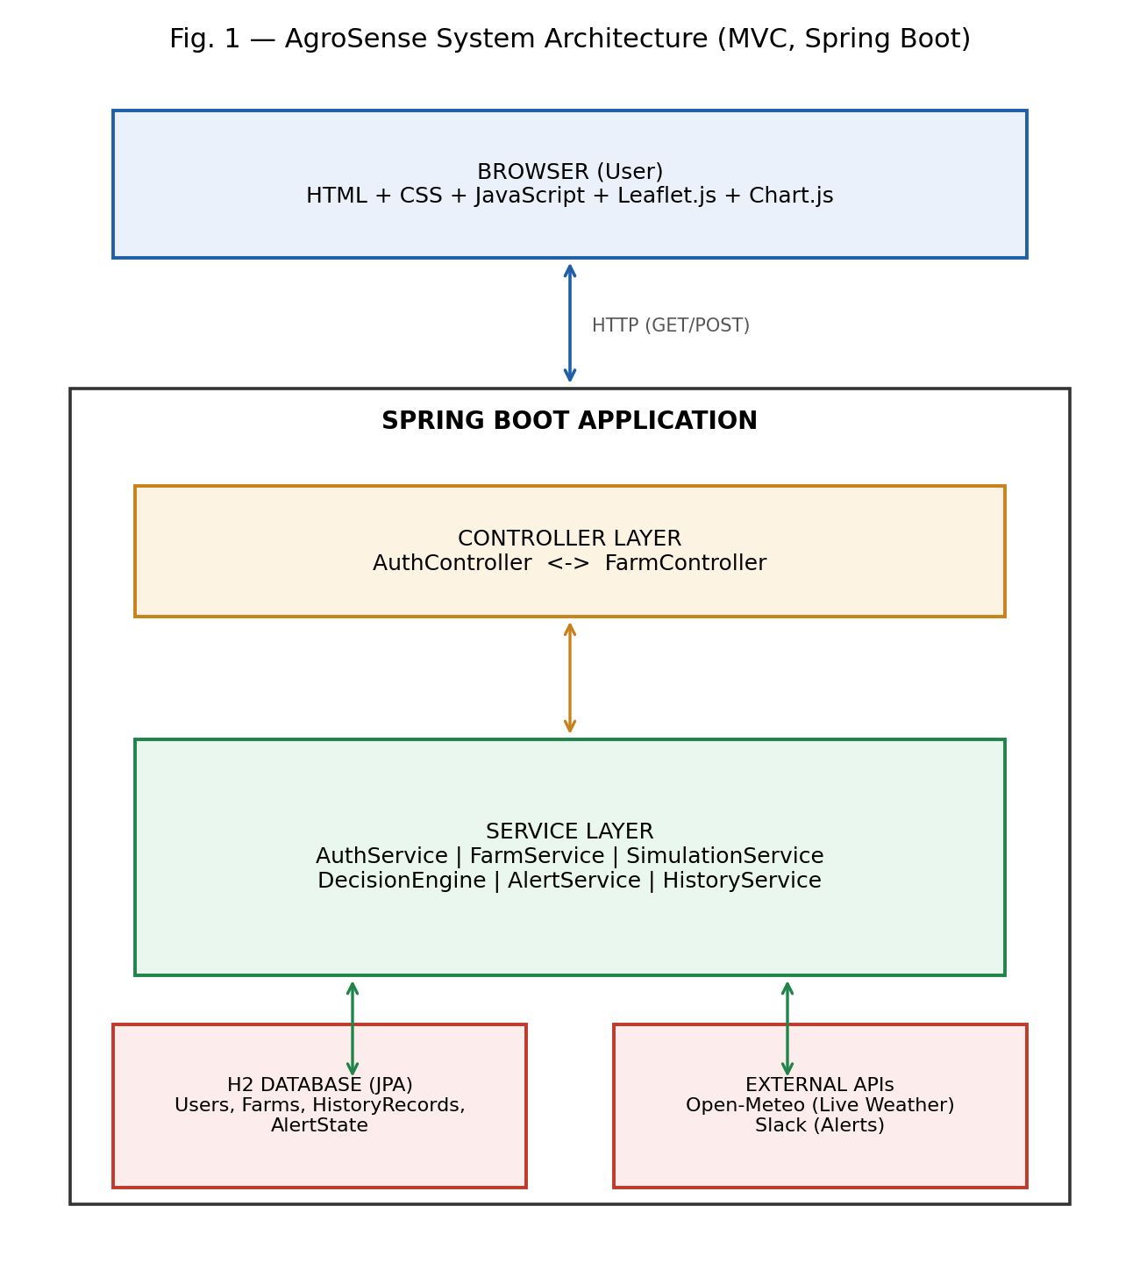
Figure 1: AgroSense System Architecture (MVC, Spring Boot)
3.2 Tools and Technologies Used
Table 1 summarises the principal tools and technologies used to build and run AgroSense.
Layer | Technology | Purpose
Backend Language | Java 17+ | Core application programming language
Backend Framework | Spring Boot 3.2.3 | Application framework and dependency injection
Web Layer | Spring MVC 6.1.4 | HTTP routing and controller layer
Persistence | Spring Data JPA / Hibernate 6.4.4 | ORM and database abstraction
Database | H2 (embedded, file-based) | Persistent storage for users, farms, and history
HTTP Client | RestTemplate (Spring Web) | Calling the Open-Meteo and Slack APIs
Frontend Templating | Thymeleaf 3.1.x | Server-side rendered HTML pages
Frontend Scripting | HTML5, CSS3, Vanilla JavaScript (ES6+) | Structure, styling, and interactivity
Mapping | Leaflet.js 1.9.4 | Interactive GPS farm-location map
Charting | Chart.js | Radar, bar, and line charts for analytics
Weather Data (Live) | Open-Meteo Forecast + Geocoding API | Real-time temperature, humidity, rainfall, weather code
Alerts | Slack Web API (chat.postMessage) | Farmer notification for critical/warning decisions
Build Tool | Maven 3.9.6 | Dependency management and build automation
Table 1: Tools and Technologies Used in the Project
No physical hardware appears anywhere in this technology stack. The only external data source that is not simulated is the Open-Meteo weather feed, which is queried live over HTTPS for every simulation run using either the farm's stored GPS coordinates or a geocoded location name.
Figure 2 traces the complete runtime flow of a single simulation, from the farmer's click on the Dashboard through to the rendered results page, showing how the six modules described below cooperate on every request.
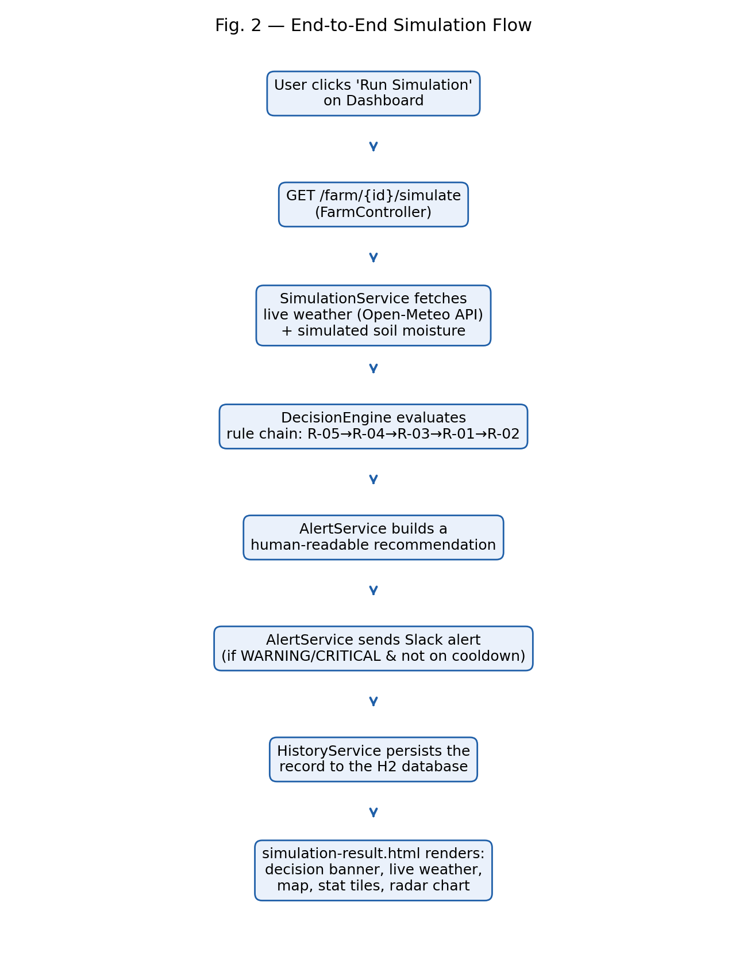
Figure 2: End-to-End Simulation Flow
3.3 Solution Overview
Module 1: Authentication
Users register with a custom user ID, display name, and password. Passwords are never stored in plain text; they are hashed with BCrypt before being persisted, and login compares the submitted password against the stored hash. A successful login stores the user object in the HTTP session, and every protected route checks for this session attribute before allowing access, redirecting unauthenticated requests back to the login page.
Module 2: Farm Management
Each authenticated user can register and manage multiple farms. When adding or editing a farm, an interactive Leaflet.js map lets the user drop a pin by clicking on the map, auto-detect their location using the browser's Geolocation API, or search for a city or village by name; the resulting coordinates are written into hidden form fields and persisted alongside the farm's crop type, soil type, and area in hectares.
Module 3: Simulation and Weather
This module is central to the project's 'no hardware, live weather' design. Every time a simulation is triggered, the Simulation Service follows a three-tier priority fallback to obtain weather data: if the farm has stored GPS coordinates, the Open-Meteo Forecast API is called directly with those coordinates (the most accurate path); if not, the farm's location name is first resolved to coordinates through the Open-Meteo Geocoding API and the Forecast API is then called; and only if both live calls fail (for example, due to a network outage) does the system fall back to a plausible simulated weather value, purely as a resilience measure. In normal operation, temperature, humidity, rainfall, and weather condition are therefore genuine, real-time values for the farm's exact location at the moment of the simulation.
Soil moisture, by contrast, is intentionally generated as a simulated value within a configurable range (10-60 percent by default) on every simulation run. This is a deliberate scope decision, documented in Chapter 1, that allows the full decision-support pipeline -- from data acquisition through to a Slack alert -- to be demonstrated and evaluated end-to-end without requiring physical soil-moisture sensor hardware; a real sensor feed could be substituted for this simulated value without any change to the modules downstream of it.
Module 4: Decision Engine
The Decision Engine evaluates the combined environmental snapshot (live weather plus simulated soil moisture) against a priority-ordered chain of five rules, summarised in Table 3 and illustrated as a flowchart in Figure 3. The chain is evaluated top to bottom, and the first matching rule determines the outcome, which prevents ambiguous or conflicting decisions.
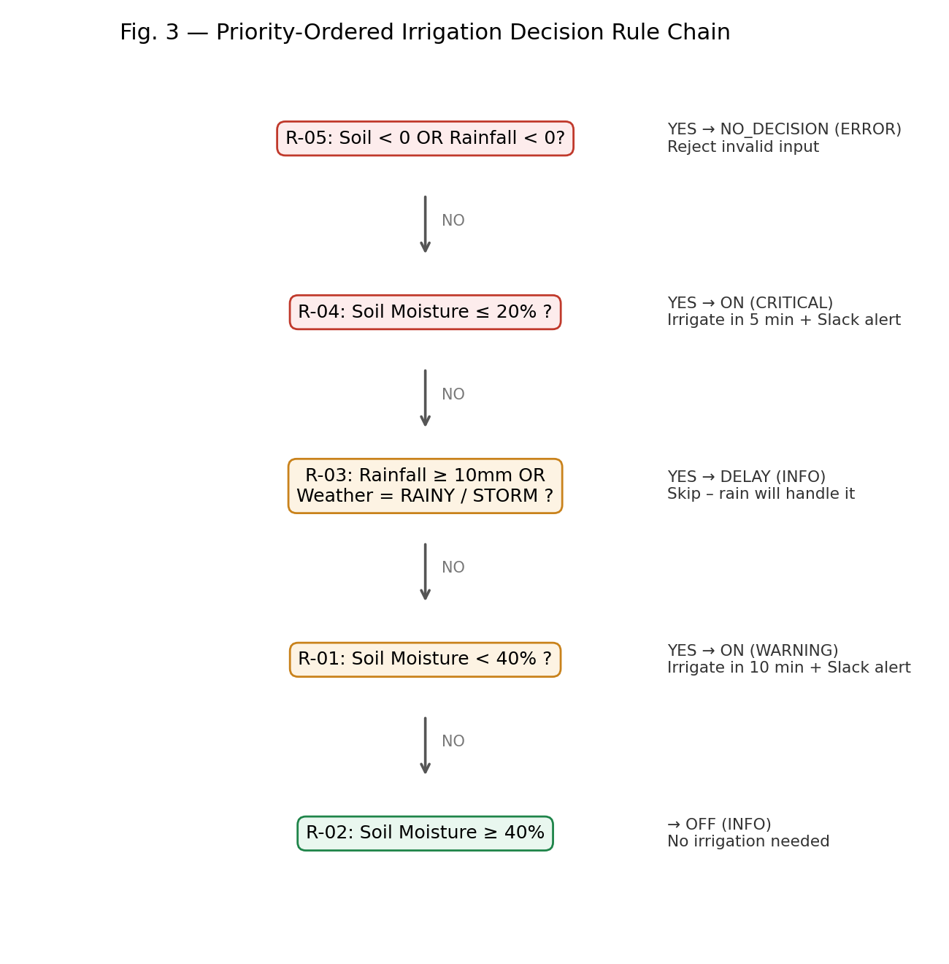
Figure 3: Priority-Ordered Irrigation Decision Rule Chain
When irrigation is required, the water quantity is computed using the following formula:
Water (L) = [(targetMoisture - currentMoisture) / 100] x farmArea(ha) x cropFactor x 10
where the target moisture is fixed at 60 percent and the crop factor reflects typical relative water demand (1.5 for rice, 1.2 for wheat, 1.0 for other crops). For example, a 5-hectare rice farm at 18 percent soil moisture yields a recommended water quantity of (60 - 18) / 100 x 5 x 1.5 x 10 = 31.5 litres. Critical decisions (soil moisture at or below 20 percent) are flagged for irrigation within 5 minutes, while warning-level decisions (soil moisture below 40 percent) are flagged for irrigation within 10 minutes.
Module 5: Alerts and Notifications
After a decision is produced, the Alert Service decides whether a Slack notification should be sent by checking, in order: whether Slack alerting is enabled and properly configured with a real bot token; whether the decision's severity is WARNING or CRITICAL (INFO-level decisions such as OFF or DELAY do not trigger an alert); and whether an alert with the same farm-and-severity fingerprint has already been sent within the configured cooldown window (30 minutes by default), to prevent alert spam. If all checks pass, a formatted message is posted to the farmer's Slack channel via the chat.postMessage API, and the outcome (SENT, NOT_CONFIGURED, NOT_REQUIRED, SUPPRESSED, or FAILED) is recorded against the simulation.
Module 6: History and Analytics
Every simulation run is persisted as a history record, including the environmental snapshot, the decision, the computed water quantity, and the Slack alert outcome. The history page supports date-range filtering and displays six KPI tiles (summarised in Table 5), a bar chart of water usage per event and a line chart of temperature and soil-moisture trends over time, illustrated for a representative 12-event sample in Figure 4.
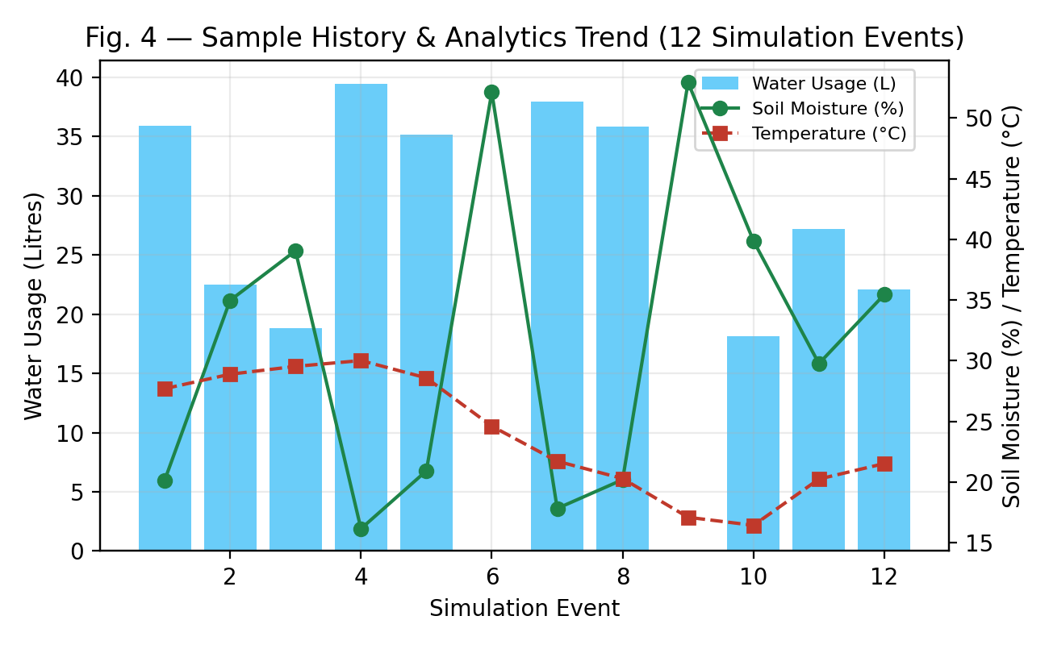
Figure 4: Sample History and Analytics Trend (12 Simulation Events)
Table 2 summarises the key fields captured across the system's three most important data models.
Model | Field | Description
Farm | cropType / soilType / farmArea | Crop, soil classification, and area in hectares
Farm | latitude / longitude | GPS coordinates pinned via the Leaflet.js map
Environmental Data | temperature / humidity / rainfall | Live values from the Open-Meteo Forecast API
Environmental Data | soilMoisture | Simulated value (10-60%), stands in for a sensor
Environmental Data | weatherCondition | Mapped from the WMO weather code (SUNNY/CLOUDY/RAINY/STORM)
History Record | irrigationStatus / ruled / waterUsage | Persisted outcome of the Decision Engine
History Record | slackStatus / slack MessageId | Outcome of the alert-dispatch attempt
Table 2: Key Data Fields Across Core Models
Rule ID | Condition | Status | Severity | Action
R-05 | Soil < 0 OR Rainfall < 0 | NO_DECISION | ERROR | Reject invalid input
R-04 | Soil Moisture <= 20% | ON | CRITICAL | Irrigate in 5 min, Slack alert
R-03 | Rainfall >= 10mm OR RAINY/STORM | DELAY | INFO | Skip - rain will handle it
R-01 | Soil Moisture < 40% | ON | WARNING | Irrigate in 10 min, Slack alert
R-02 | Soil Moisture >= 40% | OFF | INFO | No action needed
Table 3: Decision Rule Summary
3.4 Engineering Standards Applied
Table 4 summarises the engineering standards and established practices applied during the design and implementation of AgroSense.
Standard / Practice | Focus Area | Application in This Project
ISO/IEC 25010 | Software product quality model | Guided attention to reliability, usability, and maintainability across all modules
OWASP Password Storage Guidelines | Authentication security | Motivated the use of BCrypt one-way hashing instead of plain-text or reversible encryption
REST Architectural Constraints (Fielding) | API design | Informed the resource-oriented routing used in AuthController and FarmController
WMO Weather Code Standard | Meteorological data interoperability | Used to map Open-Meteo's numeric weather codes to human-readable conditions
ISO 8601 | Date and time representation | Used for all persisted timestamps (LocalDateTime) in the history log
ISO/IEC/IEEE 29148 | Requirements engineering | Structured the objectives in Section 1.2 as specific, verifiable requirements
Table 4: Engineering Standards Applied
3.5 Solution Justification
Applying OWASP password-storage guidance ensured that user credentials are never exposed even if the underlying H2 database file were compromised, which is particularly important for a system handling multiple farmers' data. Following REST-oriented routing conventions kept the controller layer predictable and easy to extend, which proved valuable when the history page's date-range filtering was added late in development without requiring any change to existing routes. Adopting the WMO weather-code standard, rather than inventing a bespoke condition classification, ensures that AgroSense's weather-condition labels remain consistent with the same standard used by the Open-Meteo API itself and by most other weather services, which reduces the risk of misinterpretation if the system is ever integrated with additional weather providers. Finally, structuring the project's objectives according to ISO/IEC/IEEE 29148 requirements-engineering practice made it possible to verify, objectively, that each objective in Section 1.2 was actually met by the delivered system, rather than relying on a subjective impression of completeness.
Chapter 4: Results and Recommendations
4.1 Evaluation of Results
The completed system was evaluated by running repeated simulations against multiple test farms with different crop types, soil types, farm areas, and GPS locations, and by verifying that each stage of the pipeline in Figure 2 behaved correctly: live weather was retrieved for the correct coordinates, the correct rule in the decision chain fired for the given soil-moisture and weather combination, the water-quantity formula produced the expected result, and the Slack alert outcome matched the expected status for the decision's severity and cooldown state.
For the worked example introduced in Chapter 3 -- a 5-hectare rice farm at 18 percent soil moisture -- the system correctly triggered rule R-01 (soil moisture below 40 percent), computed a water requirement of 31.5 litres, scheduled irrigation within 10 minutes, and dispatched a WARNING-level Slack alert on the first run; a repeated run within the 30-minute cooldown window correctly returned a SUPPRESSED alert status rather than sending a duplicate notification, confirming that the deduplication logic in the Alert Service works as designed.
Across a representative batch of 12 simulation events used to populate the History and Analytics dashboard, the system correctly logged every environmental snapshot, decision, and water-usage figure, and the resulting KPI tiles (summarised in Table 5) and trend charts (Figure 4) matched manual recalculation from the underlying history records in every case checked.
KPI | Calculation
Total Simulation Events | history.size()
Total Water Used | SUM(waterUsage)
Slack Alerts Sent | COUNT WHERE slackStatus = 'SENT'
Avg Soil Moisture | AVG(soilMoisture)
Avg Temperature | AVG(temperature)
Highest Severity | CRITICAL if any ON + waterUsage > 0, else NORMAL
Table 5: KPI Tiles and Calculations
These results confirm that a purely software-based pipeline, combining live weather data with a realistic simulated soil-moisture signal, can produce complete, auditable, end-to-end irrigation decisions -- including a computed water quantity and a farmer-facing alert -- without requiring any physical sensor hardware, directly satisfying the project's central objective.
4.2 Challenges Encountered
Several practical challenges arose during development. First, the Open-Meteo API, while reliable, is a third-party network dependency; occasional latency or transient failures required the three-tier fallback strategy described in Section 3.3 to ensure the simulation pipeline never stalls indefinitely waiting on an external call, and a final simulated-weather fallback was added purely as a resilience measure for the rare case where both live API tiers fail.
Second, correctly mapping the Open-Meteo WMO weather codes to the SUNNY/CLOUDY/RAINY/STORM categories used by the decision engine required careful review of the WMO code ranges, since a naive mapping could misclassify borderline codes and cause rule R-03 (rainfall/weather-based delay) to fire incorrectly. Third, tuning the Slack alert cooldown window required balancing responsiveness (a farmer should be notified promptly of a genuinely new critical condition) against alert fatigue (the same condition should not generate a new Slack message every few minutes); the 30-minute default was chosen after testing shorter and longer windows and observing which produced the most useful, non-repetitive notification pattern in the test data.
4.3 Possible Improvements
The most significant possible improvement, consistent with the project's explicit scope boundary, is the replacement of the simulated soil-moisture generator with a real IoT sensor feed (for example, over MQTT or a REST push endpoint); because the Decision Engine already treats soil moisture as an opaque input field on the EnvironmentalData model, this substitution would require no change to the decision logic itself. Other improvements include migrating from the embedded H2 database to a concurrent multi-user database such as PostgreSQL, adding role-based access control for agricultural extension officers who manage multiple farmers' accounts, and introducing a scheduled (rather than manually triggered) simulation job so that decisions and alerts are generated automatically on a fixed interval.
4.4 Recommendations
Based on the results of this project, the following recommendations are made:
- Prioritise integration of a real IoT soil-moisture sensor feed as the first hardware addition, since the software architecture already isolates this input cleanly behind the EnvironmentalData model.
- Migrate from the embedded H2 database to PostgreSQL or MySQL before deploying the system for concurrent multi-user production use.
- Add Spring Security with distinct Farmer and Admin/Extension-Officer roles to support agricultural cooperatives managing many farmers from one account.
- Introduce a scheduled simulation job (using Spring's @Scheduled annotation) so that irrigation decisions are generated automatically at a fixed daily interval rather than only on manual trigger.
- Add an email-based alert channel alongside Slack, since not every smallholder farmer will have ready access to a Slack workspace.
- Package the application as a Docker container and deploy it to a cloud platform to make it accessible beyond a local development environment.
Chapter 5: Reflection on Learning and Personal Development
This chapter reflects on the learning journey undertaken while designing, building, and evaluating AgroSense, assessing both the academic and professional growth achieved over the course of this capstone project.
1. Key Learning Outcomes
Academic Knowledge
This project deepened my understanding of layered software architecture, particularly how a Model-View-Controller design keeps business logic (the irrigation decision rules) cleanly separated from data acquisition (live weather calls and simulated soil moisture) and from presentation (the Thymeleaf dashboard). I also gained a much stronger practical understanding of RESTful integration with third-party APIs, including how to design a system so that an external dependency's occasional unavailability does not compromise the whole application.
Technical Skills
On the technical side, I developed hands-on proficiency with the Spring Boot ecosystem, including Spring MVC, Spring Data JPA, and Hibernate, as well as with Thymeleaf server-side templating, Leaflet.js for interactive maps, and Chart.js for data visualisation. I also learned how to design and secure a simple authentication system using BCrypt password hashing, and how to integrate a messaging platform's API (Slack) with deduplication logic to avoid alert fatigue -- a skill directly transferable to other notification-heavy systems.
Problem-Solving and Critical Thinking
The most significant problem-solving challenge was designing the three-tier weather-data fallback strategy described in Chapter 4. My first implementation simply called the Open-Meteo API and let the request fail visibly if the network was unavailable, which made the whole simulation pipeline fragile. Working through this problem taught me to think about external dependencies in terms of graceful degradation rather than all-or-nothing success, a mindset I expect to carry into future backend-engineering work.
2. Challenges Encountered and Overcome
Personal and Professional Growth
There were moments of frustration, particularly when early versions of the Decision Engine produced inconsistent results because the rule chain was not strictly priority-ordered, allowing two rules to appear to conflict for the same input. Diagnosing this required stepping back and redesigning the rule chain as a strict, top-to-bottom priority sequence (Figure 3) rather than a set of independent conditions, which was a valuable lesson in the importance of explicit control flow when implementing any rule-based system.
Collaboration and Communication
Although much of the implementation work was individual, I regularly discussed design decisions -- particularly the choice of soil-moisture simulation ranges and the Slack cooldown window -- with my project guide and with peers who had some exposure to agricultural practice. These conversations taught me to explain technical trade-offs (such as why soil moisture is simulated while weather is live) in plain language to people without a software background, which is a skill I expect to need throughout my career.
3. Application of Engineering Standards
Applying OWASP password-storage guidance and REST design conventions, described in Chapter 3, changed how I approach even small student projects: I now default to hashing credentials and designing resource-oriented routes as a matter of habit rather than an afterthought. Structuring the project's objectives according to ISO/IEC/IEEE 29148 principles also taught me to write requirements that can be objectively verified, which made it much easier to demonstrate, in Chapter 4, that the delivered system actually met each stated objective.
4. Insights into the Industry
This project gave me a clearer picture of how AgriTech products are actually built in industry: rarely as a single monolithic sensor-to-cloud pipeline, but usually as a layered software platform that can absorb different data sources -- live weather APIs, simulated placeholders, and eventually real sensor feeds -- behind a stable set of internal data models. This insight has shaped my career interest toward backend and platform-engineering roles in applied domains such as agriculture and sustainability, where software design decisions have a direct, practical impact on resource use.
5. Conclusion of Personal Development
Overall, this capstone project meaningfully advanced both my technical and professional development. It required me to integrate knowledge of software architecture, secure authentication, third-party API integration, rule-based decision systems, and data visualisation into a single coherent, working product, and it forced me to think carefully about resilience and graceful degradation when depending on external live data sources. The skills and engineering habits developed during this project will directly support my future goals in backend and platform engineering.
Chapter 6: Conclusion
This capstone project set out to demonstrate that a credible irrigation decision-support system can be built entirely in software, without any physical IoT hardware, by combining live real-time weather data with a realistic simulated soil-moisture signal. AgroSense, the resulting Spring Boot web application, implements this idea end-to-end: it retrieves live temperature, humidity, rainfall, and weather-condition data from the Open-Meteo Forecast API for each farm's exact GPS coordinates, combines this with a configurable simulated soil-moisture value, and passes the result through a transparent, priority-ordered rule chain that produces an irrigation decision, a computed water quantity, and, where appropriate, an automated Slack alert to the farmer.
Evaluation against representative test farms and a 12-event simulation history confirmed that the system's decisions, water-quantity calculations, and alert-deduplication logic all behave as designed, and that the resulting KPI dashboard and trend charts accurately reflect the underlying simulation history. The project also surfaced a clear and low-risk path to further hardware integration: because soil moisture is treated as an isolated input field throughout the architecture, a real IoT sensor feed could be substituted for the simulated value at any time without requiring any change to the Decision Engine, Alert Service, or History module.
The broader value of this project lies in showing that the absence of physical sensor hardware need not mean the absence of meaningful, real-time-aware irrigation decision support. By anchoring the system in genuine live weather data rather than simulating every input, AgroSense demonstrates a realistic, immediately deployable middle ground between no decision support at all and a full IoT sensor deployment, and the recommendations in Chapter 4 provide a clear roadmap for evolving the system toward that fuller deployment over time.
References
- Open-Meteo. (2026). Open-Meteo Weather Forecast API documentation. Retrieved from https://open-meteo.com/
- Slack Technologies. (2026). Slack Web API reference: chat.postMessage. Retrieved from https://api.slack.com/methods/chat.postMessage
- Spring Team, VMware. (2026). Spring Boot reference documentation (Version 3.2.x). Retrieved from https://docs.spring.io/spring-boot/
- OWASP Foundation. (2023). Password Storage Cheat Sheet. Retrieved from https://cheatsheetseries.owasp.org/
- ISO/IEC 25010:2011. Systems and software engineering -- Systems and software Quality Requirements and Evaluation (SQuaRE) -- System and software quality models. ISO.
- ISO 8601:2019. Date and time -- Representations for information interchange. ISO.
- ISO/IEC/IEEE 29148:2018. Systems and software engineering -- life cycle processes -- requirements engineering. ISO.
- World Meteorological Organization. (2019). Manual on codes: WMO weather interpretation codes. WMO.
- Fielding, R. T. (2000). Architectural styles and the design of network-based software architectures (Doctoral dissertation). University of California, Irvine.
- Food and Agriculture Organization of the United Nations. (2020). AQUASTAT: Global information system on water and agriculture. FAO.
- Jones, H. G. (2004). Irrigation scheduling: Advantages and pitfalls of plant-based methods. Journal of Experimental Botany, 55(407), 2427-2436.
Appendices
Appendix A: Decision Engine Rule Chain (Java Excerpt)
The following excerpt shows the core priority-ordered rule chain implemented in DecisionEngine.java, together with the water-quantity calculation described in Section 3.3. The full source code, including the Simulation, Alert, and History services, is available in the project repository.
public IrrigationDecision evaluate(EnvironmentalData data, Farm farm) {
// R-05: invalid input guard
if (data.getSoilMoisture() < 0 || data.getRainfall() < 0) {
return IrrigationDecision.noDecision("Invalid sensor input");
}
// R-04: critical soil moisture
if (data.getSoilMoisture() <= 20.0) {
return buildDecision(data, farm, "ON", "R-04", "CRITICAL", 5);
}
// R-03: rain expected - delay
if (data.getRainfall() >= 10.0 || isRainyOrStorm(data.getWeatherCondition())) {
return IrrigationDecision.delay("Rain will handle irrigation");
}
// R-01: warning-level low soil moisture
if (data.getSoilMoisture() < 40.0) {
return buildDecision(data, farm, "ON", "R-01", "WARNING", 10);
}
// R-02: sufficient moisture
return IrrigationDecision.off("Soil moisture sufficient");
}
private double computeWaterLitres(double current, double target,
double farmAreaHa, double cropFactor) {
return ((target - current) / 100.0) * farmAreaHa * cropFactor * 10.0;
}
Appendix B: Application Configuration (application.properties Excerpt)
The following excerpt shows the key configuration values controlling the database connection, Slack alerting, the simulated soil-moisture range, and the decision-rule thresholds.
# Server
server.port=8080
# Database
spring.datasource.url=jdbc:h2:file:./data/smart-irrigation-db
spring.jpa.hibernate.ddl-auto=update
# Slack Alerts
slack.enabled=true
slack.bot.token=xoxb-...
slack.channel.id=C...
# Simulation Ranges (soil-moisture simulation, no hardware used)
simulation.soil-moisture.min=10.0
simulation.soil-moisture.max=60.0
# Decision Rules
rule.soil-moisture.critical=20.0
rule.soil-moisture.threshold=40.0
rule.rainfall.threshold=10.0
rule.cooldown.minutes=30
Appendix C: Pages and Screens
Page | URL | Description
Login | / | Authentication with a gradient logo header
Register | /register | User registration with input validation
Dashboard | /dashboard | Farm grid with glassmorphism cards
Add Farm | /farm/add | Form with a Leaflet.js interactive GPS map
Edit Farm | /farm/{id}/edit | Pre-populated form with a movable map pin
Simulation Result | /farm/{id}/simulate | Decision banner, live weather, map, charts, Slack status
History & Analytics | /farm/{id}/history | KPI tiles, Chart.js visualisations, filterable table
Logout | /logout | Clears the session and redirects to Login
Table C1: Pages and Screens Provided by the Application

